Section 6 - Software Development:
READ MEEE
Variables & Data Structures:
El Aziz’ Databases
Database Name | Description
tblCustomers | A database that holds all customer data such as their name, date of birth, email address etc.
tblStaff | A database that holds all staff data such as their personal information as well as their schedules for shifts.
tblAdmin | A database that holds all the admin’s data such as their name, date of birth, email address etc.
tblMenu | A database that holds all the menu’s data like the menu items, quantity, description,
tblOrders | A database that holds the orders data such as their order number, order, cost, quantities and menu items
tblReservations | A database that holds the data of customer reservations such as their reservation name, phone number, table number, date and time of reservation, number of guests and any special requests
tblShifts | A database that holds the data of Staff’s shifts such as the date, start and end time, staff name, salary and area of work.
tblStock | A database that holds the data about Stock, including stock levels, item name, availability, price per unit etc.
tblPayments | A database that holds the data of User payments such as their first and surname, email address, phone number, total cost, payment method and the status of their payment.
tblReports | A database that holds the data about the restaurant reports such as the number of sales, profits made, most popular item, peak times etc.
tblLoginLogs | A database that holds the data about login/entry in the system such as their ID, time of entry and time of exit.

El Aziz’ Subroutines
Subroutine Name | Description
create_database() | A subroutine holding all the databases, to seperate it from the rest of the program. This subroutine is called first and the databases are created, ready to store the user's input. It imports the SQLite library as well.
account_creation () | A subroutine that manages the task of creating an account. It creates a new window/screen. This subroutine is executed if the suer clicks the button to ‘Create an Account’. User will fill out all details and proceed to create an account. All data is saved to the corresponding database.
submit_user() | A subroutine inside of the account_creation() subroutine. This subroutine validates all of the user’s entries through various validation checks. It also generates a unique ID for the user depending on their role selection.
login() | A subroutine that handles user logins. It creates a new screen/window to perform the task. Prompts users to login via username and password, using a form of encryption to hide the typed password.
submit_login() | A subroutine inside the login() subroutine. It contains the checks for all data connected to the account logged into. Also contains test data for the login log aspect since I couldn’t program it efficiently. Gathers username and password, checks it and then informs of its success or failure.
insert_menu_items() | A subroutine to insert all menu items into the tblMenu database. It lists the items using the SQL command to select ALL items, counting them for the table format. Displays menu item, price and item description.
dashboard (role,roleID) | A subroutine to create the dashboards, depending on the user’s role within El Aziz. Contains a heading and back button. It creates a new window for the user dashboard. This subroutine holds all of the main procedures/functions within the program for all customers, staff and admin.
browse_menu() | A subroutine that creates a new window/screen for customers to browse the menu. Displays all the menu items in a box /frame that is scrollable. Users scroll to find items. Also, includes a search bar to search for items via binary search. Contains a bubble sort and data handling via SQL.
binary_search_menu() | A subroutine inside the browse_menu() subroutine. Once data has been sorted via Bubble sort, it can be searched through a binary search. Creates a midpoint and searches different halves depending on data presence. Searches for menu items, despite the scrollable frame.
create_order() | A subroutine for customers to create an order. Creates a new screen for this task. Lists the menu items, providing them with a checkbox and bar to specify quantity. User will specify quantity before selecting item. Contains a function that calculates total costs, returning it.
update_total() | A subroutine inside create_order() containing the function to calculate and return total cost to customer, in real time. Contains loop to find selected items and their quantities. Multiplies item price by quantity, adding to total. Inserted into tblOrders.
submit_order() | A subroutine inside create_order() that contains a count controlled loop that collects the users selected items and quantities. Inserts the order into tblOrders.
create_reservation() | A subroutine that allows customers to create reservations. Creates a new screen for this task. Gather user input via fields of entry to successfully book a reservation.
submit_reservation() | A subroutine inside create_reservation(). It processes and saves the reservation by checking and validating data entries. Once checked, it is inserted into tblReservations, saving all data.
view_orders_ reservations() | A subroutine that opens a new screen to show the customers orders and reservations. It retrieves data form database, performing a linear search to find current customers orders and reservation. Sorts the data via Insertion sort by total Price. Sorts reservations via Bubble sort by date. Allows customers to search for an order or reservation by ID., displaying results in the scrollable frame as a list.
manage_account() | A subroutine that displays the current users account details in a new screen. Retrieves all their data from their relevant tbale based on their role. It uses a linear search to find the users data by ID. Displays user’s information on the screen.
view_shifts() | A subroutine that displays the shifts for the current member of staff in a new screen. Inserts a default shift since I coudlnt program it (test data). Retrieves all the shifts data and performs a linear search to find a shift belonging to the user. Displays the shift details on screen.
view_databases() | A subroutine that displays the selected database tables for staff in a new screen. Retrieves data from relevant tables and presents them on screen in a scrollable frame as a list.
view_active_orders() | A subroutine that displays all orders and reservations for staff to view in a new screen. It sorts the data by order date/time using a bubble sort. Displays the data in a simple list in a scrollable frame.
view_all_shifts() | A subroutine that displays all staff shifts for admin to view in a new screen. Retrieves all shift data from each staff member and displays it on the new screen.
view_all_databases() | A subroutine that retrieves and displays all database tables from the system on the new screen.
order_new_stock() | Unfinished subroutine intended to alert admin of stock levels and allow them to order new stock.
view_reports_analytics() | Unfinished subroutine intended to inform admin of most popular items, profit, number of sales etc.
manage_accounts() | A subroutine that retrieves and displays all staff, customers and admin accounts and details. Retrieves data from each table and displays it in a scrollable frame in the form of a list.

El Aziz’ Variables (GUI)
Variable Name | Description
tk.StringVar() | TKinter variable that stores and updates text values dynamically in the GUI.
firstName | Stores the user’s first name input from the GUI.
surname | Stores the user’s surname input from the GUI.
email | Stores the user’s email input from the GUI.
phone | Stores the user’s phone number input from the GUI.
username | Stores the username entered in the GUI.
password | Stores the password entered in the GUI.
date_var | Stores the reservation date input from the user.
time_var | Stores the reservation time input from the user.
guests_var | Stores the number of guests input.
special_var | Stores any special requests entered by the user.
search_var | Stores input used for searching records.
textVarHeader | Stores the text displayed in the main header label.
textVarContact | Stores the contact information text displayed on the home screen.
tk.IntVar() | Tkinter variable used to store integer values.
role | Stores the selected user role from customer, staff, or admin.
selections[item_id] | Stores whether a menu item is selected.
tk.DoubleVar() | Tkinter variable used to store decimal values.
total_var | Stores and updates the total price of an order.
homeScreen | The main program window (home screen).
accountScreen | Window displaying entry fields to create an account.
loginScreen | Window displaying entry fields to login to an account.
dashboardScreen | Main dashboard window after login. Displays tasks depending on role within system.
menuScreen | Window displaying the menu items.
orderScreen | Window used to create an order.
reservationScreen | Window used to create a reservation.
viewScreen | Window displaying orders and reservations.
shiftsScreen | Window displaying staff shifts.
databaseScreen | Window displaying selected database tables.
reportScreen | Unfinished window for reports and analytics.
stockScreen | Unfinished window for ordering new stock.
manageScreen | Window for managing accounts.
activeOrdersScreen | Window displaying active orders and reservations.
form | Frame used to organise input fields in the GUI.
frame | Container used to group widgets together.
role_frame | Frame used to group role selection radio buttons.
entry_user | Entry widget for username input.
entry_pass | Entry widget for password input.
entry() | Tkinter widget used to create input fields.
label() | Tkinter widget used to display text.
listbox | Widget used to display lists of data.
scrollbar | Widget used to enable scrolling in lists.
btn_create | Button used to create an account.
btn_login | Button used to log into account.
btn_... | A button that allows users to complete their task or progress forward.
selections | Stores selected menu items.
quantities | Stores quantities for selected menu items.

El Aziz’ Variables
User | Variable Name | Visibility | Description
Customer | connection | Local | Connects to SQLite database ‘ElAziz.db’ to access and store customer data
 | cursor | Local | Executes SQL queries to insert or retrieve customer data
 | customerID | Local | Stores unique customer ID
 | reservations | Local | List storing the customer’s reservation records
 | row | Local | Temporary variable storing a single record during a loop.
 | target | Local | Stores search value (e.g order ID)
 | index | Local | Loop counters used for iteration in the searches and sorts.
 | found | Local | Boolean indicating if search item was found
 | n | Local | Stores length of list for sorting algorithms
 | index2 | Local | Secondary loop counter/index used in insertion sort
 | current | Local | Stores current value being compared in insertion sort
 | temp | Local | temporary variable used for swapping values during sorts
 | swapped | Local | Boolean used in bubble sort to check if swaps have occurred
 | username | Local | Stores the customer's account username.
 | password | Local | Stores the customer's account password.
 | role | Global | Stores user role as either Customer, Staff or Admin
 | roleID | Global | Stores ID of current logged in user
 | userID | Local | Stores unique ID for user
 | firstName | Local | Stores customers first name
 | surname | Local | Stores customers surname
 | email | Local | Stores customers email address
 | phone | Local | Stores customers phone number
 | menu_items | Local | A list storing all menu items retrieved from tblMenu
 | item | Local | Represents single menu item during loops
 | item_id | Local | Stores ID of specific menu item
 | quantity | Local | Stores number of items selected by customer
 | order_items | Local | List storing items selected for a single order
 | totalPrice | Local | Stores total cost of an order
 | reservationDate | Local | Stores the customers selected reservation date
 | reservationTime | Local | Stores the customers selected reservation time
 | numberOfGuests | Local | Stores number of guests selected by customer
 | specialRequests | Local | Stores special requests made by customers
 | all_orders | Local | List storing all orders retrieved from tblOrders
 | all_reservations | Local | List storing all reservations retrieved from tblReservations
 | orders | Local | List storing sorted orders belonging to customer.

User | Variable Name | Visibility | Description
Staff | connection | Local | Connects to SQLite database ‘ElAziz.db’ to access and store staff data
 | cursor | Local | Executes SQL queries to insert or retrieve staff data
 | firstName | Local | Stores staff member’s first name
 | surname | Local | Stores staff member’s surname
 | email | Local | Stores staff member’s email address
 | phone | Local | Stores staff member’s phone number
 | username | Local | Stores staff member’s username
 | password | Local | Stores staff member’s password
 | role | Global | Stores the user’s role as a customer, staff or admin
 | roleID | Global | Stores the ID of the current logged in staff member
 | all_shifts | Local | List storing all shift records from tblShifts
 | found_shifts | Local | List storing shifts that belong to the current staff member
 | row | Local | Temporary variable used to store a single record during a loop
 | index | Local | Loop counter used for iteration in searches
 | found | Local | Boolean indicating is search item was found (shifts)
 | all_orders | Local | List storing all order records from tblOrders
 | all_reservations | Local | List storing all reservation records from tblReservations
 | n | Local | Stores the length of a list for sorting algorithms
 | temp | Local | Temporary variable used to swap values during sorting algorithms
 | swapped | Local | Boolean used to indicate if swap has occurred in a bubble sort
 | table | Local | Stores the name of database table being accessed
 | rows | Local | Stores records retrieved from database table
 | staffID | Local | Stores unique staff ID
 | hours | Local | Stores the number of hours worked in a shift
 | startTime | Local | Stores the start time of a shift
 | endTime | Local | Stores the end time of a shift

User | Variable Name | Visibility | Description
Admin | connection | Local | Connects to SQLite database ‘ElAziz.db’ to access and store admin data
 | cursor | Local | Executes SQL queries to insert or retrieve admin data, all tables and system data
 | all_databases | Local | List storing all database tables on the system
 | all_shifts | Local | List storing all staff shift records
 | role | Global | Stores user’s role as customer, staff or admin
 | roleID | Global | Stores ID of the logged in admin account
 | table | Local | Stores the name of database table being accessed
 | rows | Local | Stores records retrieved from a database table
 | firstName | Local | Stores admin’s first name
 | surname | Local | Stores admin’s surname
 | email | Local | Stores admin’s email address
 | phone | Local | Stores admin’s phone number
 | username | Local | Stores admin’s username
 | password | Local | Stores admin’s password
 | adminID | Local | Stores admin’s unique ID
 | all_customers | Local | List storing all customer record from tblCustomers
 | all_staff | Local | List storing all staff records from tblStaff
 | row | Local | Temporary variable used to store single record during a loop
 | all_admins | Local | List storing all admin records from tblAdmin
 | count | Local | Stores the number of admin records
 | table | Local | Stores the name of current table being processed, used in loops
 | rows | Local | Stores rows retrieved from each table during iteration

User Interface:

CUSTOMER POINT OF VIEW:
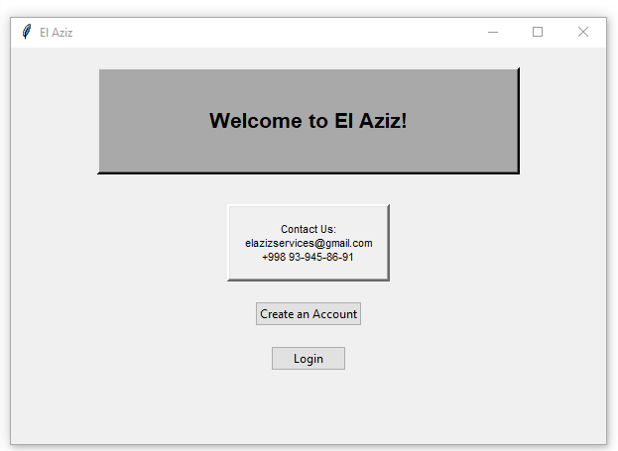

This is the home screen of the program. When the program is first run, users will be faced with this screen. Users have the option to either create an account or login to an already existing account, registered in our database. This is very similar to the prototype, still maintaining the minimal user interface. Unfortunately, I did not incorporate the photos and bold, vibrant colours due to limited time and expertise in performing. The colour scheme and empty space will not overwhelm the user. The contact information is outlined in a box to catch the user’s attention. The big heading ‘Welcome to El Aziz!’ makes the user aware they are using El Aziz’s restaurant management system. The buttons are spaced out and are labelled with the task option to complete, informing the user clearly. This demonstrates clear and intuitive navigation, improving user experience.

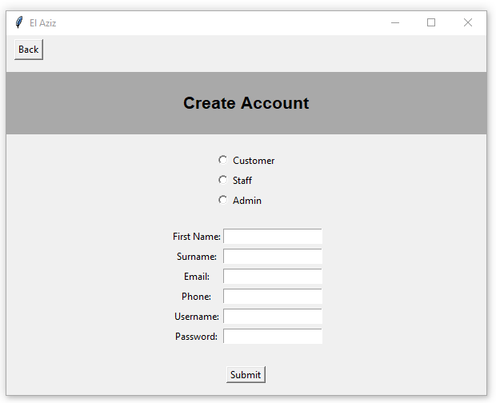
If the user chooses the option to ‘Create an Account’, the program creates and opens a new window to complete the individual task. This improves navigation making it easier to complete and track task completion. The back button at the top allows users to return to the home screen, with the program closing the current window down. The heading ‘Create Account’ in bold informs the user of their current task. Users are prompted to select their role within the system, by selecting the checkbox next to the role title. Then, they must fill out the fields of entries to successfully create an account. The fields are all created by entry bars and each field is validated by the program to ensure the data is valid. All fields of entry require a presence check, as this data cannot be null. The first name and surname are length checked to ensure they are suitable. The email address is validated via format check, to check for the presence of a ‘@’ symbol and ‘.’ The phone number is validated via type and length check to ensure the entry is an integer and is 11 digits long. The username requires a length check to ensure it is appropriate. Finally, the password is length checked to maintain security, reducing unauthorised access. The typed password is displayed with ‘*’, protecting the password as a form of encryption. The user will submit their entries and if validation fails, they are alerted. Once successful, the account is created and the window will close itself.

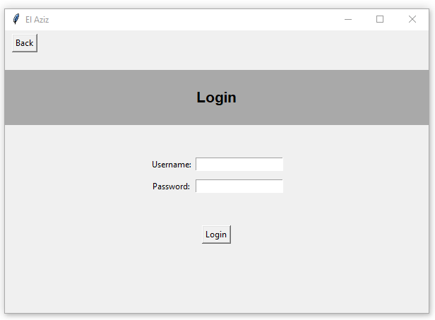
If the user created an account, their ‘Create Account’ window will close and they will return to the home menu, where they must click the option to login. To login, the user is required to enter their username and password, which would have been stored in the database. When the user enters their password, it will be replaced with ‘*’ again, encrypted to protect the user’s account and personal information. The navigation of the window is very easy and clear, with a bold heading informing the user of their current task. The program performs a check to find the stored username and password, to find a match. If either the password or username is incorrect, the message ’Login Failed!’ is shown on the screen in red writing, alerting them. Once the user has entered their username and password, and it’s correct (a match), they are successfully logged into the system. Users have the option to go back, which closes the current window, returning to the home screen.

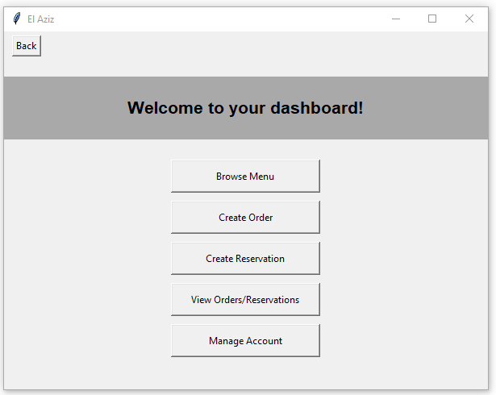
Customers are shown their dashboard in a new window, once they have successfully logged in. This is the customer dashboard, presenting them with 5 tasks to complete, some mandatory and some optional. The dashboard is organised, ranking tasks n chronological order. The buttons are large, labelled with their task to complete. The heading in bold writing informs user of their current place in the system. The tasks are presented as buttons, with users clicking them to take them to new windows to complete the tasks. The buttons improve navigation and make it easier and faster to go through the system. The buttons are centred to make it more visible to user.

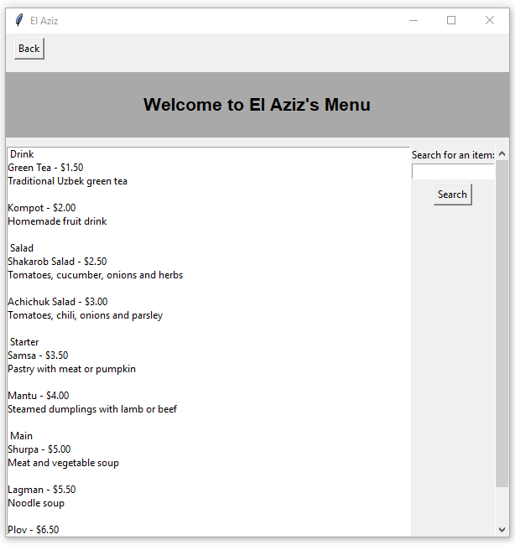

From the dashboard, if the customer selects ‘Browse Menu’ they will be taken to this new window, where they can view the menu. Customers will be able to look at El Aziz’s menu and the dishes they offer, as well as their prices and desecrations of dishes. The new screen has a large and bold heading displaying ‘Welcome to El Aziz’s Menu’ which informs user that they are looking at the menu. If users do not wish to be at this stage yet, they can click the ‘back’ button located in the top left corner, where this current window will be closed down and they are left with the dashboard window. The menu is displayed differently to the prototype. The prototype prioritises aesthetics whereas this program prioritises usability and efficiency. The amount of menu items made the window sizing situation difficult, since not all of the menu items could be seen. So I implemented the scrollable frame for this window. The white box lists all the menu items, categorised into starters, drinks, main and salads. The scroll bar along the right side of the screen controls the white box listing, allowing customers to scroll and view more menu items. It clearly displays the item cost and a description, making it more efficient. The menu also has the option to search for a menu item, making it quicker for customers to find what they want and order. The search by menu item name is a binary search, bubble sorting the menu items first before the binary search. This makes optimises searching efficiency, making it suitable for the large menu. The navigation is easy and clearly. At first glance it can look overwhelming, however it is way more efficient and practical.
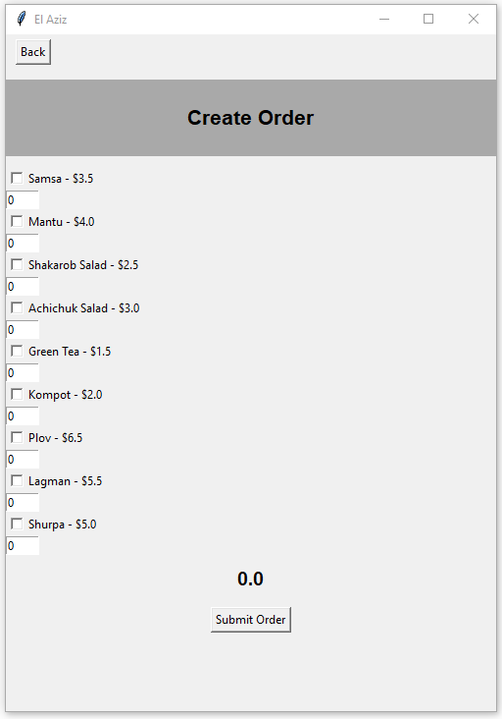

This is the ‘Create Order’ window. Once users have browsed the menu they can return to the dashboard and select the option to ‘Create Order’. Here, customers are listed with all menu items available and can select the item they want to order, as well as specify the quantity they would like. Automatically, the balance at the bottom of the window is updated as they select more items. For this to work accurately, customers must specify the quantity of the item they would like before they select the actual item. Once the user is happy with their order, they simply click ‘Submit Order’ and return to the dashboard since the ‘Create Order’ window is closed. The navigation of this is clear and appears easy, however it can be confusing to customers. Logically, you would select the item first and then specify the quantity, however I had issues trying to program it this way. The ordering is made easier by selecting items and specifying quantities, with an automatic cost calculated in comparison to hand writing customer orders and calculating by hand or calculator, which takes time. The system improves efficiency and speed of ordering, improving customer satisfaction.
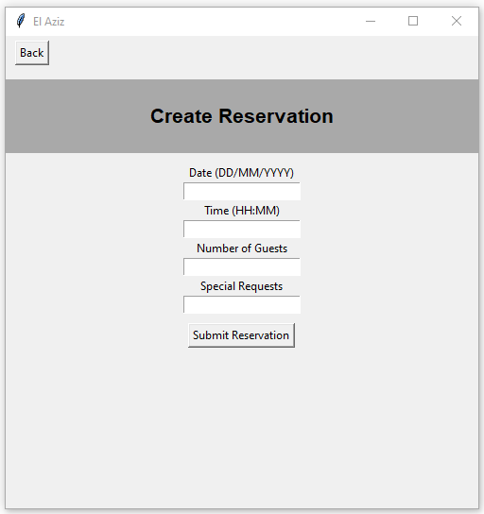

This is the ‘Create Reservation’ window. Once users have successfully created an order, they can return to the dashboard. Usually, you would book a reservation before creating an order, however making reservations are optional therefore it is placed lower in the order of completion. Booking a reservation is made easy with the simple fields of entry. Customers are expected to fill this ‘form’ out specifying the reservation date, time, number of guests and any special requests. This is then stored to the reservations table in the database. The task is easy to navigate, with clear and simple instructions. The fields of entry also instruct users of the correct format to use, reducing errors and improving organisation. Once they have filled out the fields, they can submit their reservation, and it will be stored to the reservation table. Then, this window will be closed down, returning customers to their dashboard. The appearance of the window is minimal and the process is simple and easy, satisfying customers with quick completion and minimal errors faced.

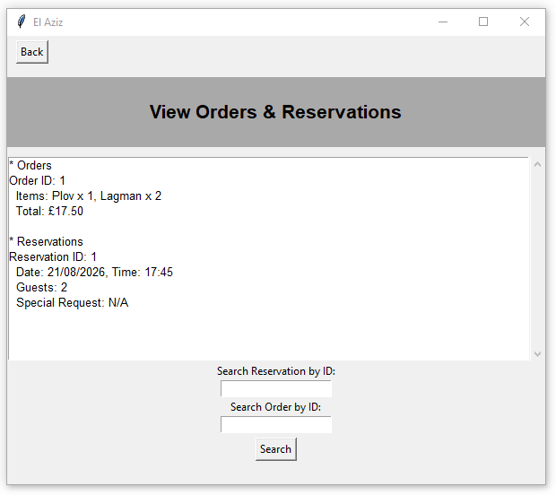

This is the ‘View Orders & Reservations’ window. Ultimately, once the customer has created a reservation or order (or both), they will be able to view these orders and reservations made. By selecting the option to ‘View Orders & Reservation’ on their dashboard, they are taken to this window. The orders and reservations are given a generated ID for identification, which is noted in relation to their orders/reservations. The order or reservation details are displayed in the scrollable frame, making it clear to view. The scrollable frame allows users to scroll down, to view all history of orders and reservations created. If a customer wants to find a previous or active order/reservation, they are able to search for the order or reservation by typing in the ID it was assigned. The program will then perform a linear search to find the orders/reservations. The navigation of this window is simple and clear with scrollbars and search bars improving the programs efficiency. The data is clear to see and organised efficiently. Once users have found their orders/reservations or are compete with this task, they can click the ‘back’ button to return to their dashboard.
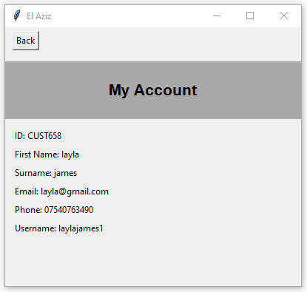
Finally, this is the ‘My Account’ window. If users click ‘Manage Account’ on their dashboard they are taken to this new window. Customers are able to view their account details such as their customerID, username and their personal information. Their password is not displayed to protect their safety, in the case of unauthorised access. However, this does raise concerns for account lifespan, due to the inability to reset passwords or view them in the case the customer forgets, which can frustrate customers. The display of information is clear and organised appropriately, making it easier for customers to find their details if necessary. Once users are complete with this, they can press the ‘back’ button to return to their dashboard, where they have successfully completed all tasks.

STAFF POINT OF VIEW:
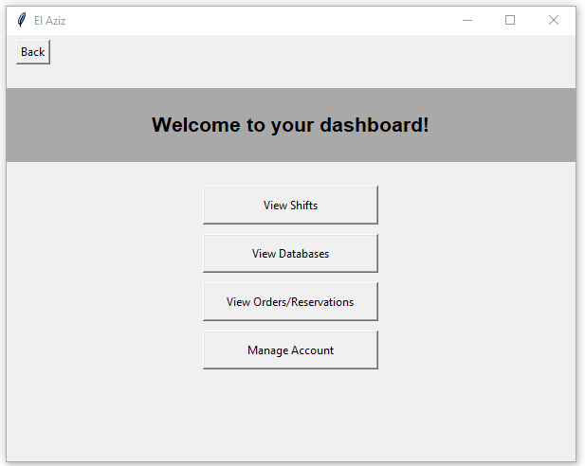
This is the Staff’s perspective of their dashboard. In comparison, staff have less tasks than customers, however this is due to the nature of their role within the system. The system is much more customer and user focused, to improve their management and customer satisfaction levels. Once a member of staff have successfully logged in, they are displayed this dashboard. Staff have the option to view shifts, view databases, view active orders & reservations, and manage their account. The display of this dashboard is clear, minimal and easy to navigate. Buttons are clearly labelled with the task to complete, informing the user of what button to complete which task. There is a lot of grey space to not overwhelm the staff member, and make navigation easier, especially during busy and peak times.

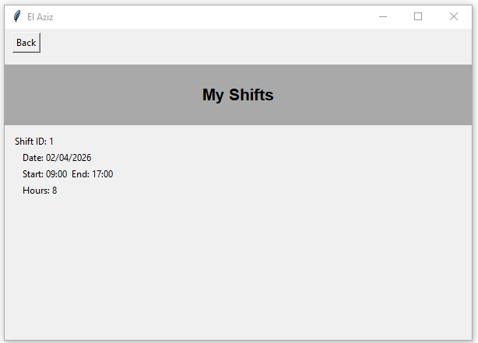

This is the ‘View Shifts’ window. Once the user has clicked the button to ‘View Shifts’ on their dashboard, they will be directed to this window where they can view their shift details. It will only display that specific staff members shifts when created by admin or manager. When programming this, I used test data to demonstrate this shift viewing, since in real life, I would expect the manager to regulate the shift routers. The shifts ID, date, start and end time as well as hours worked are listed, clear for the staff to view. This allows staff to view their shifts in advance of work, making it easier for them to plan around their schedule. The appearance of this window is clean, simple and clear which improves staff experience, making their workload easier. Once the staff member has viewed their shift details, they can press the ‘back’ button, located in the top left corner, to return to their dashboard.
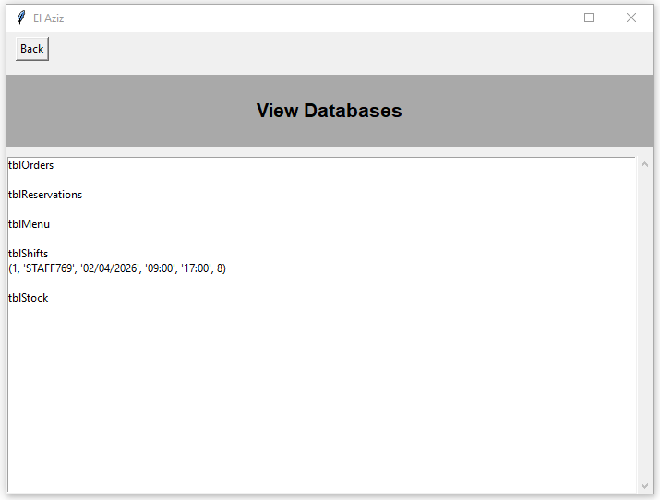
This is the ‘View Databases’ window. Once staff members have clicked the option to ‘View Databases’ they are taken to this window, where all relevant databases, such as orders, reservations, stock levels, menu and the shifts, are listed for display. This is quick and easy viewing, instead of opening an excel spread sheet or actual database. This improves efficiency and staff speed, as they can quickly view the orders, reservations and stock levels in real time, making decisions based off this data. This is better and safer than storing all orders, reservations and stock levels in a notebook at a front desk. This will increase staff productivity and reduce stress and pressure. The navigation of this window is easy and clear, with a scrollbar to view more data, as the list grows larger. The organisation of data by table makes it easier to identify specific records. Once the staff is done viewing the databases, they simply click the ‘back’ button in the top left corner to return to their dashboard. To improve efficiency, I could add a search feature, searching for records rather than scrolling, however that could be a future development as it would be difficult to search for data without a specific and common filter.
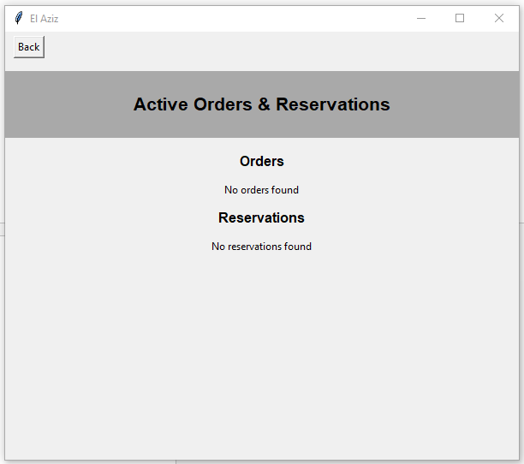
This is the ‘View Active Orders & Reservations’ window. If staff click ‘View Orders/ Reservations’ on their dashboard, they are taken to this window, where they can view active orders and reservations. The order of orders and reservation will be sorted by date and time, placing earlier made orders/reservations at the top, in levels of priority. This will make it easier for staff to view and complete. The reservations and orders are sorted using a bubble sort, ordering records by date and time of creation. By having this feature, staff can quickly view the incoming orders and reservations, helping them prepare and complete on time. Once staff have viewed the orders or reservations, they can click the ‘back’ button to return to their dashboard, closing this window down.
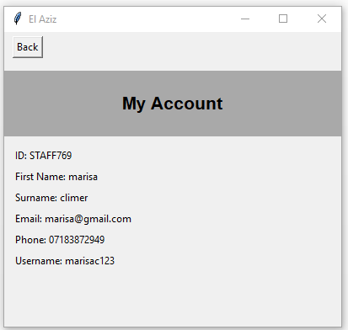
Finally, this is the ‘Manage Account’ window. If a staff member choose the option to ‘Manage Account’ they will be displayed this window where they are shown their account details, exactly the same way as customers account management. Staff will be shown their StaffID, personal information and username, making it easy and quick access if necessary. Staff’s passwords are not displayed for security reasons, however this can limit account recovery and frustrate staff members. The information is displayed in an organised format (list) and is clear to see, improving usability. Once staff members are done with viewing, they can return to their dashboard by clicking the ‘back’ button.

ADMIN POINT OF VIEW:
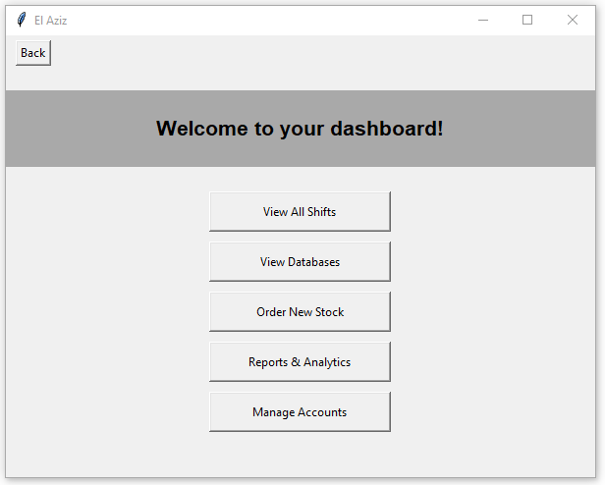
This is the Admin’s dashboard perspective. As a member of admin, they are presented with more tasks, management/maintenance and access. The presentation of tasks on this dashboard is clear, with each button indicating the task to complete. The window contains a lot of grey space to not overwhelm the user, especially when faced with this many tasks. Each button is linked to a new window to complete each task. On this dashboard, the tasks ‘Order New Stock’ and ‘reports & Analytics’ are listed, however due to limited time and client demand, these features are unfinished and unavailable for use. The display of them there is to demonstrate what I would look like to the admin, and still allows for the opportunity of future development.

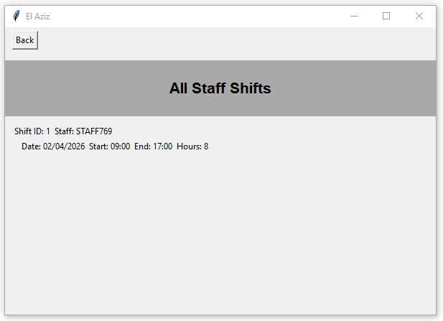
This is the ‘View Shifts’ window. As an admin, they have unrestricted access rights, giving them the right to view all staff shifts to manage and create their schedules. They can also update them onto the system, improving functionality. If admin select the option to ‘View Shifts’ they are taken to this window, presented with shift details in the same way as from a staff perspective. The information is clear and organised. However, a limiting factor with this is that due to the inability to connect to El Aziz’s real shift database, test data was used, making this amount of shifts unrealistic. As their staff team is quite large, the simple display could be inefficient, as it wouldn’t fit onto the window. Therefore, implementing a scrollable frame would improve functionality, allowing large volumes of shifts to be sorted and viewed, without adjusting window size. With this growing volume of data, a search function could be added to search for individual staff shifts to take registration. However, the current display of shifts is clear and functional for the volume of data it has. Once complete viewing, they can click the ‘back’ button to return to their dashboard.

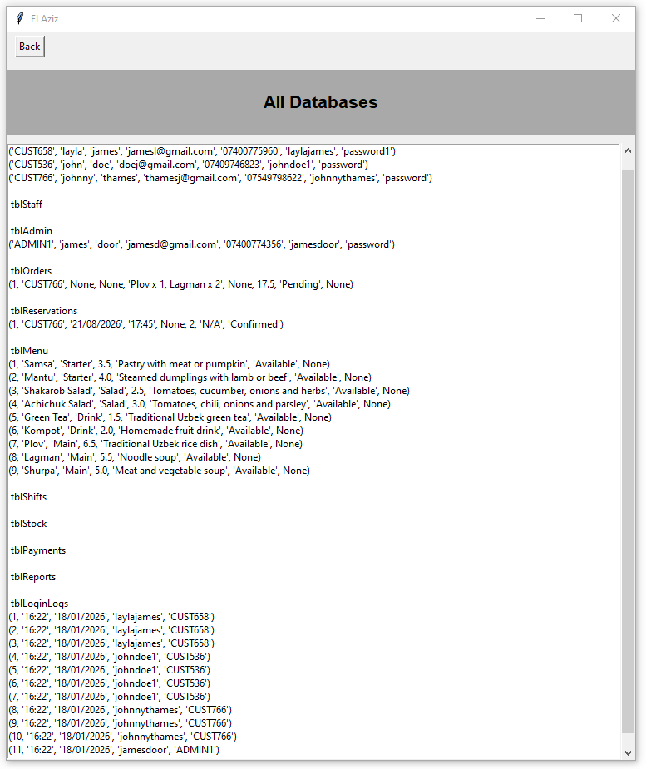
This is the ‘View Databases’ window. Once the admin has selected the ‘View Databases’ button they are directed to this window, where they can view all databases and their records sorted. This window is efficient as it utilises a large scrollable frame allowing the admin to scroll and identify data from the database table. It improves functionality, as it can store the large volume of database records onto the window size as is, without readjusting. The organisation of data is simple, efficient and doesn’t take up a lot of space which reduced number of lines. It also makes identification easier, as all the data is stored on one line. The viewing of all databases, allows admin to view all stored records, finding and managing records when necessary. Implementing a binary search could optimise the searching and identification process of records. Once viewing is complete, admin can click the ‘back’ button to return to their dashboard.
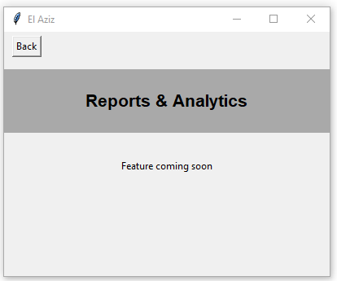
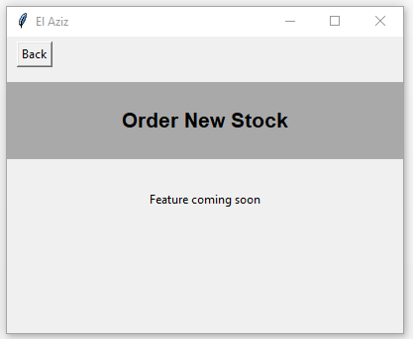
These are the two unfinished features of the program. The ‘Reports & Analytics’ and ‘Order New Stock’ features were left unfinished due to limited time and resources. Although these features significantly impact the business knowledge and management, these features do not compromise customer experience, which is why they were left unfinished. This is a chance for future development and can be implemented later on, but just not right now. The ‘Reports and Analytics’ feature required libraries that I was inexperienced with which would’ve required additional time to learn and practice. Similarly, ordering new stock would also have been too complicated and time consuming to program with the time I had left. Therefore, this decision was made purely based on these factors. The windows, headings and formatting have been programmed in advance to the future development, giving admin users a glimpse of what it would look like.
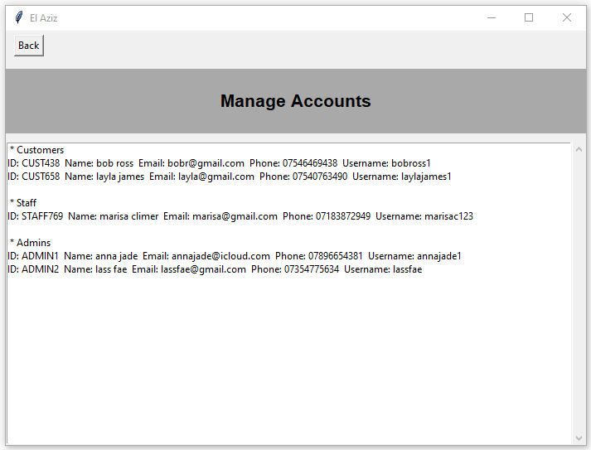
Finally, this is the ‘Manage Accounts’ window. Once admin have clicked the option to ‘Manage Accounts’ they are shown this window, listing all accounts registered and created within the system. The account details such as their ID (implying their role), personal information and usernames are displayed. This allows admin to manage accounts and users, searching and identifying account if necessary. To improve this feature, implementing a binary search could be useful to speed up the identification process, especially as this volume of records will grow as the number of users increase. At times of high demand, searching for an account via binary search would please users and improve system efficiency. Otherwise, the display and organisation of data is clear and optimal, limiting each record to a single line. Once users are done viewing, they can return to their dashboard via the ‘back’ button, completing all tasks.

